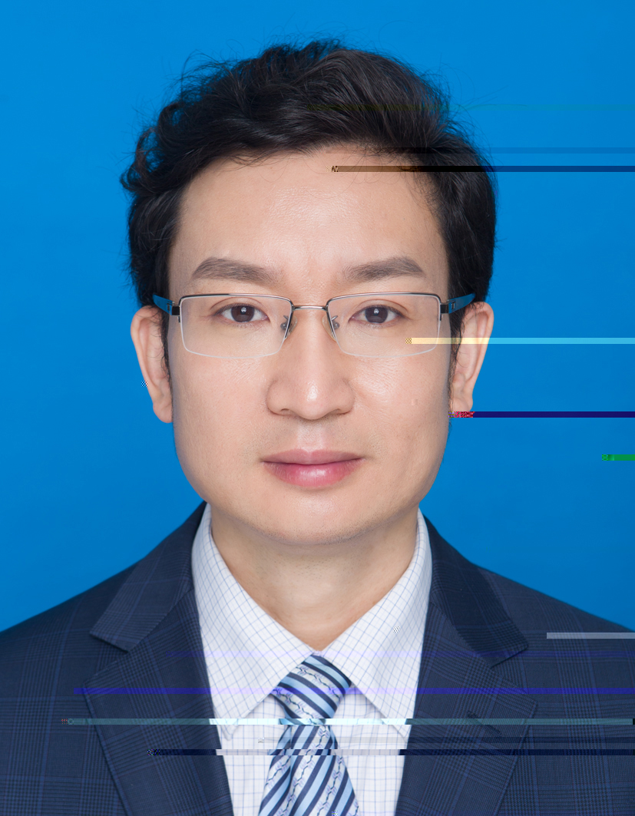
基本信息
- 东南大学特聘教授，博士生导师
- 国家重点研发计划项目首席
- 教育部新世纪优秀人才，江苏省“六大人才高峰”
- CCF杰出会员、IEEE高级会员
- CCF服务计算专委常务委员、CCF协同计算专委常务委员
- 中国仿真学会智能仿真优化与调度专业委员会常务委员
- 联系方式：xpli@seu.edu.cn
- 个人主页：http://www.scholat.com/xpli
- 研究方向：云计算、调度优化、服务计算、云制造、人工智能算法
年度招生（欢迎报考！！！）
- 至善博士后或博士后1-2人/年
- 全日制博士生1-3人/年，非全日制工程博士0-1人/年
- 硕士生4-7人/年

主要科研项目
[1] 国家重点研发计划项目：专业科技资源及服务集成技术（No. 2017YFB1400800），2017.12-2020.11，项目负责人，1330万
[2] 国家重点研发计划课题：开放式资源及服务集成模型与机理（No. 2017YFB1400801），2017.12-2020.11，课题负责人，320万
[3] 国家自然科学基金项目：带数据安全等级约束的云服务工作流调度（No. 61872077）. 2019.01-2022.12，项目负责人，64万
[4] 国家自然科学基金重点项目：大数据环境下的大服务理论与方法研究（No. 61832004）. 2019.01-2023.12，合作单位负责人，70万
[5] 国家自然科学基金项目：云计算环境下多尺度计费服务的批任务工作流调度（No.61572127），2016.1-2019.12，项目负责人，66万
[6] 国家自然科学基金项目：带有资源依赖学习效应的多模态项目调度交互式群智能方法（No. 61272377），2013.1-2016.12，项目负责人，82万
[7] 国家自然科学基金项目：基于无冲突集的约束Job Shop调度优化算法（No. 60973073），2010.1-2012.12，项目负责人，30万
[8] 国家自然科学基金项目：基于服务计算的一类不可分解调度问题自适应算法（No. 60672092），2007.1-2009.12，项目负责人，22万
[9] 国家自然科学青年基金项目：基于目标增量的大规模无等待调度复合启发式算法（No. 60504029），2006.1-2008.12，项目负责人，22万
[10] 国家863计划项目：基于SOA的高可用车间作业计划与调度协同优化新技术（No. 2008AA04Z103），2008.10-2010.10，项目负责人，71万
[11] 国家科技支撑计划项目：制造业信息化标准与规范研究（No. 2006BAK04A20-9），2007.11～2010.9，课题负责人，24万

近5年代表性期刊论文
- Shuang Wang, Xiaoping Li*, Ruben Ruiz. Performance analysis for heterogeneous cloud servers using queueing theory. IEEE Transactions on Computers, 2020, 69(4): 563-576. (CCF A类)
- Shuang Wang, Xiaoping Li*, Quan Z. Sheng, Ruben Ruiz, Jinquan Zhang, and Amin Beheshti. Multi-Queue Request Scheduling for Profit Maximization in IaaS Clouds. IEEE Transactions on Parallel and Distributed Systems. 2021, 32(11): 2838-2851. (CCF A类)
- Jie Zhu, Xiaoping Li*, Rubén Ruiz, Wei Li, Haiping Huang, Albert Y. Zomaya. Scheduling Periodical multi-stage jobs with fuzziness to elastic cloud resources. IEEE Transactions on Parallel and Distributed Systems, 2020, 31(12): 2819-2833. (CCF A类)
- Jie Zhu, Xiaoping Li*, Rubén Ruiz, Xiaolong Xu. Scheduling Stochastic Multi-stage Jobs to Elastic Hybrid Cloud Resources. IEEE Transactions on Parallel and Distributed Systems. 2018, 29(6): 1401-1415. (CCF A类)
- Xiaoping Li, Lihua Qian, Rubén Ruiz. Cloud workflow scheduling with deadlines and time slot availability. IEEE Transactions on Services Computing. 2018, 11(2): 329-340. (CCF B类)
- Xiaoping Li, Wei Yu, Rub´en Ruiz, Jie Zhu. Energy-aware cloud workflow applications scheduling with geo-distributed data. IEEE Transactions on Services Computing, 2020, DoI:10. 1109/ TSC .2020.2965106 (CCF B类)
- Xiaoping Li, Fuchao Chen, Rubén Ruiz, Jie Zhu. MapReduce task scheduling in heterogeneous geo-distributed data centers. IEEE Transactions on Services Computing, Accepted, Doi: 10.1109/TSC.2021.3092563 (CCF B类).
- Zhicheng Cai, Xiaoping Li*, and Jatinder N. D. Gupta, Heuristics for provisioning services to workflows in XaaS Clouds, IEEE Transactions on Services Computing. 2016, 9(2): 250 -263. (CCF B类)
- Long Chen, Xiaoping Li*, Ruben Ruiz. Resource renting for periodical cloud workflow applications. IEEE Transactions on Services Computing. 2020, 13(1): 130-143. (CCF B类)
- Jia Wang, Xiaoping Li*, Rub´en Ruiz, Jie Yang, Dianhui Chu. Energy Utilization Task Scheduling for MapReduce in Heterogeneous Clusters. IEEE Transactions on Services Computing, 2020, Doi: 10.1109/TSC.2020.2966697 (CCF B类)
- Guangshun Yao, Qian Ren, Xiaoping Li*, Shenghui Zhao, Rubén Ruiz. A hybrid fault-tolerant scheduling for deadline-constrained tasks in Cloud system. IEEE Transactions on Services Computing, DoI: 10.1109/TSC.2020.2992928 (CCF B类)
- Yamin Wang, Xiaoping Li*, Rubén Ruiz, Shaochun Sui. An iterated greedy heuristic for mixed no-wait flowshop problems. IEEE Transactions on Cybernetics. 2018. 48(5):1553-1566. (CCF B类)
- Yadi Wang, Xiaoping Li*, Rubén Ruiz. Weighted General Group Lasso for Gene Selection in Cancer Classification. IEEE Transactions on Cybernetics. 2019, 49(8): 2860-2873. (CCF B类)
- Xiaoping Li, Yadi Wang, Rub´en Ruiz. A survey on sparse learning models for feature selection. IEEE Transactions on Cybernetics. Accepted. (CCF B类)
- Xinye Cai, Wenxue Sun, Mustafa Misir, Kay Chen Tan, Xiaoping Li, Tao Xu, Zhun Fan. A Bi-objective Constrained Robust Gate Assignment Problem: Formulation, Instances and Algorithm. IEEE Transaction on Cybernetics, 2019, DOI: 10.1109/TCYB.2019.2956974. (CCF B类)
- Xiaoping Li, Zhicheng Cai. Elastic Resource Provisioning for Cloud Workflow Applications. IEEE Transactions on Automation Science and Engineering. 2017, 14(2):1195-1210. (CCF B类)
- Xiaoping Li, Yi Zhang. Adaptive hybrid algorithms for the sequence- dependent setup time permutation flow shop scheduling problem. IEEE Transactions on Automation Science and Engineering. 2012, 9(3):578-595. (CCF B类)
- Long Chen, H. Burak Gunay*, Zixiao Shi, Weiming Shen, Xiaoping Li. A metadata inference method for building automation systems with limited semantic information. IEEE Transactions on Automation Science and Engineering, 2020, 17(4): 2107-2119. (CCF B类)
- Jie Zhu, Xiaoping Li. An effective meta-heuristic for no-wait job shops to minimize makespan. IEEE Transactions on Automation Science and Engineering. 2012, 9(1): 189-198. (CCF B类)
- Xiaoping Li, Yulu Jiang, Rubén Ruiz. Methods for Scheduling Problems Considering Experience, Learning, and Forgetting Effects. IEEE Transactions on Systems, Man, and Cybernetics: Systems. 2018, 48(5): 743-754. (中科院1区)
- Yamin Wang, Xiaoping Li, Rubén Ruiz. An Exact Algorithm for the Shortest Path Problem With Position-Based Learning Effects. IEEE Transactions on Systems, Man, and Cybernetics: Systems. 2017, 47(11): 3037-3049. (中科院1区)
- Haiyan Xu, Xiaoping Li*, Ruben Ruiz, Haihong Zhu. Group scheduling with nonperiodical maintenance and deteriorating effects. IEEE Transactions on Systems, Man, and Cybernetics: Systems. 2021, 51(5): 2860 - 2872. (中科院1区)
- Zhicheng Cai, Xiaoping Li, Ruben Ruiz. Resource provisioning for task-batch based workflows with deadlines in public clouds, IEEE Transactions on Cloud Computing, 2019, 7(3): 814-826. (CCF C类)
- Long Chen, Xiaoping Li*, Yucheng Guo, Rubén Ruiz. Hybrid resource provisioning for cloud workflows with malleable and rigid tasks. IEEE Transactions on Cloud Computing, DOI: 10.1109/ TCC.2019. 2894836. (CCF C类)

